IBM ASSIGNMENT- I

**TEAM ID :PNT2022TMID26673**

**NAME :MONICA SELES.B**

**ROLL NO : 212919106056**

Create a circuit with Piezo alarm, PIR Sensor, TMP Sensor with below functionalities:

* Alarm should sound in one manner if temp is above 60C
* Alarm should sound with another frequency if motion is detected in PIR Sensor.

# CIRCUIT LAYOUT:

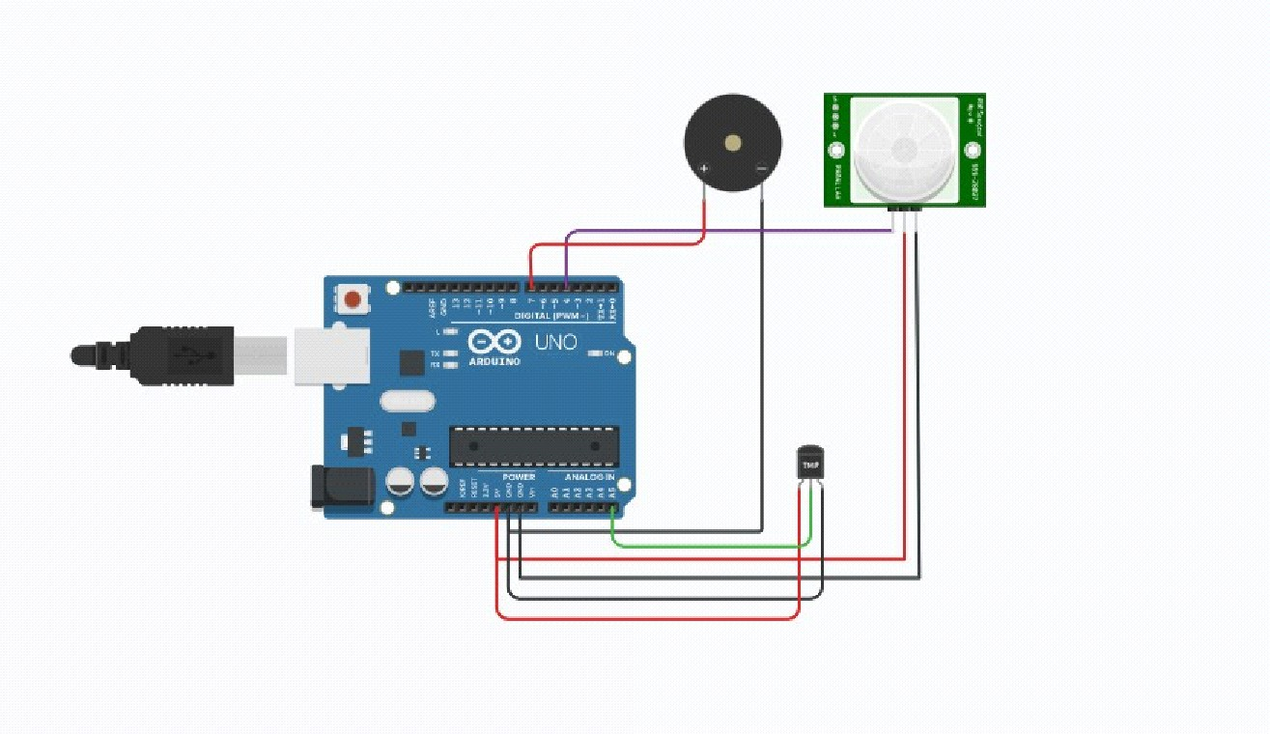

**CODE:**

// C++ code

//

void setup()

{

Serial.begin (9600); pinMode(4, INPUT); pinMode(7,OUTPUT); pinMode(A5,INPUT);

}

void loop()

{

int motion = digitalRead(4); if (motion==1){

Serial.println("Motion detected"); tone (7,200);

delay(350);

}

else{

Serial.println("No Motion"); noTone(7);

}

{

double data=analogRead(A5); double n=data/1024;

double volt=n*5; double off=volt-0.5;

double temperature=off*100; if (temperature>59.99){

Serial.print("Temperature data:"); Serial.println(temperature); tone(7,1000);

delay(350);

}

else

Serial.print("Temperature data: "); Serial.println(temperature); noTone(7);

}

}

# OUTPUT:

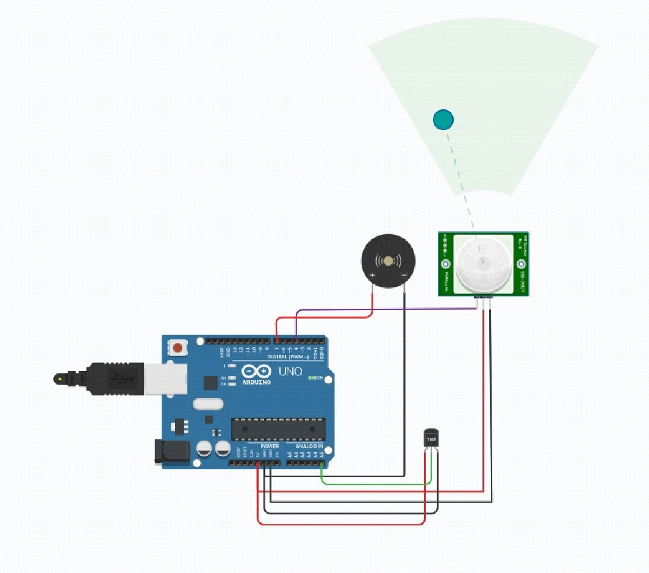**PASSIVE INFRARED SENSOR:**

**TEMPERTURE SENSOR (AT 60°C):**

